**Requirement Gathering and Analysis Phase**

**Solution Architecture**

|  |  |
| --- | --- |
| Date | 11-07-2024 |
| Team ID | SWTID1720167264c |
| Project Name | Cab Booking App |
| Maximum Marks | 2 |

**Solution Architecture:**

Solution architecture is a complex process – with many sub-processes – that bridges the gap between business problems and technology solutions. Its goals are to:

* Find the best tech solution to solve existing business problems.
* Describe the structure, characteristics, behavior, and other aspects of the software to project stakeholders.
* Define features, development phases, and solution requirements.Provide specifications according to which the solution is defined, managed, and delivered.

**User Authentication:**

Users can log in or sign up.

User authentication is handled by the backend, and upon successful authentication, user details are stored in localStorage.

**Navigation:**

After authentication, users navigate to the landing page.

From the landing page, users can view cab details, book a cab, access their account details, or log out.

**Account Management:**

Users can view and edit their account details on the My Account page.

The system fetches account details from the backend.

**Cab Booking:**

Users can view available cabs and their details.

To book a cab, users fill out the ride details (pickup and drop locations).

The ride details are posted to the backend, which responds with a confirmation.

**Booking Management:**

Users can view their bookings on the My Bookings page.

The system fetches booking details from the backend.

**Logout:**

Users can log out, which likely clears their session and localStorage data.

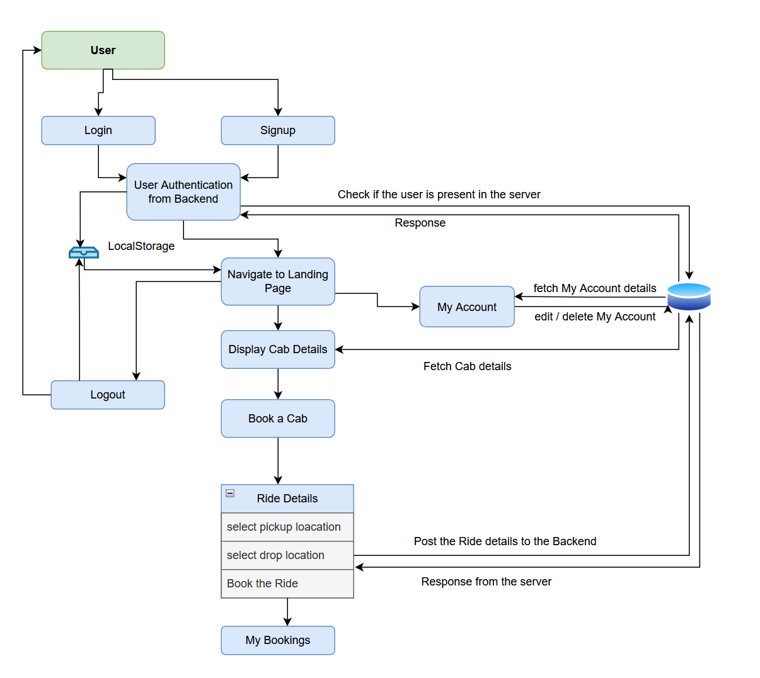

Figure 1: Solution envisioned

**Reference:** [**https://aws.amazon.com/blogs/industries/voice-applications-in-clinical-research-powered-by-ai-on-aws-part-1-architecture-and-design-considerations/**](https://aws.amazon.com/blogs/industries/voice-applications-in-clinical-research-powered-by-ai-on-aws-part-1-architecture-and-design-considerations/)

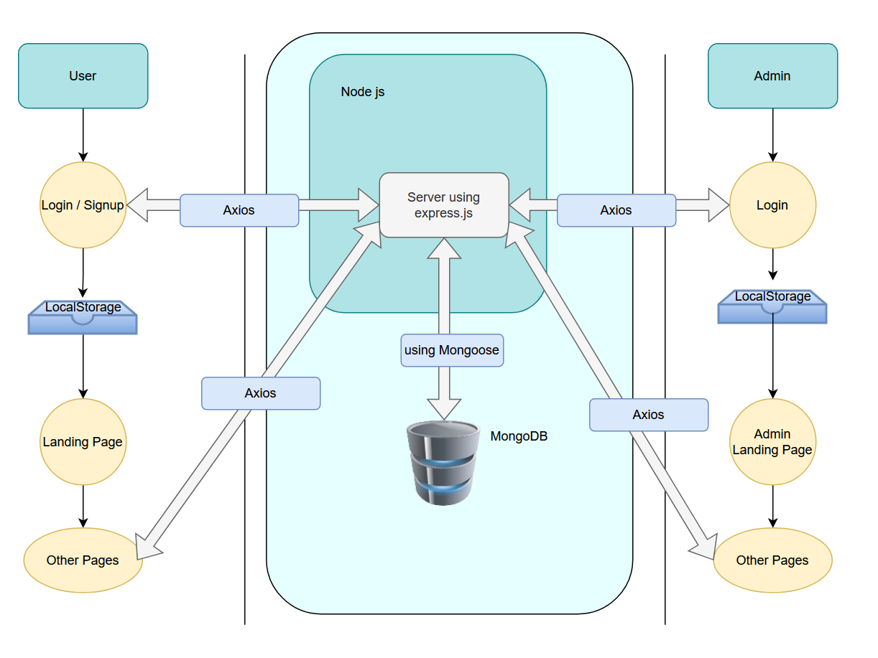

Figure 2: Architecture Diagram